32.37: a) The energy incident on the mirror is 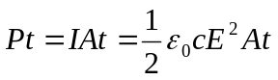
b) The radiation pressure 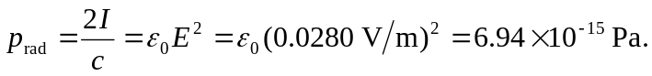
c) Power 